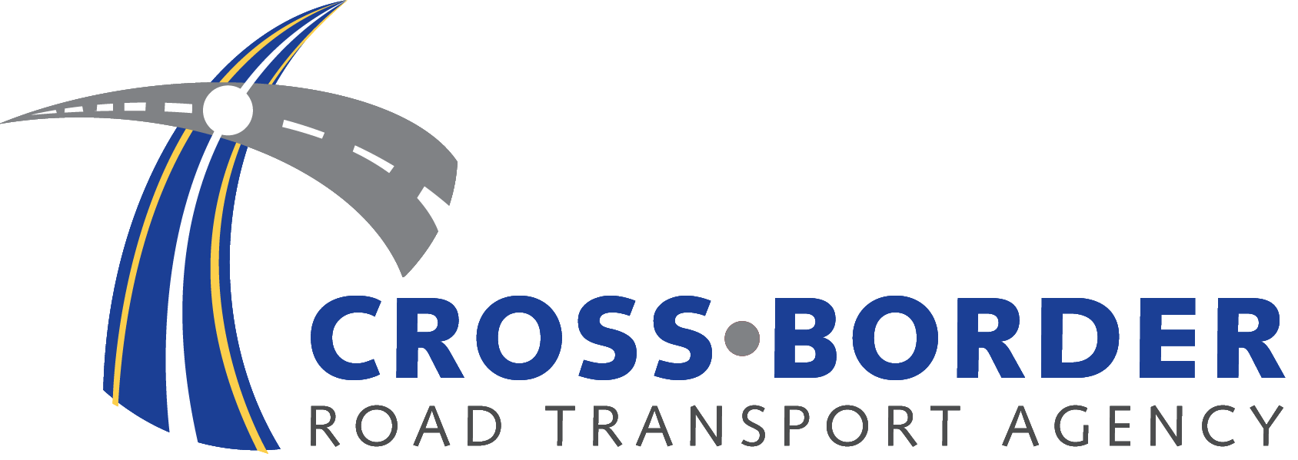

REVENUE ACCOUNTANT
Ref: FIN 003/06/2021

THE EMPLOYER

The Cross-Border Road Transport Agency is a statutory authority, established in terms of Section 4 of the Cross-Border Road Transport Act, 4 of 1998, as amended, to regulate cross-border road transport.

The incumbent will have to ensure the efficiency, effectiveness, uniform planning and execution of procurement of services and goods required for the functioning of CBRTA. She/he will be required to manage the sale and letting of assets that conforms to legislative principles and preferential goals.

The position will be based at the Agency’ Head Office in Ecopark Centurion. He/she will report directly to the Senior Manager: Finance.

REQUIREMENTS:

  - B.Com Honours (Accounting)
  - Completed Articles
  - 5 years in Financial Management with particular experience related to revenue.
  - Computer literacy, full MS Office Package and Accounting Software.

KEY PERFORMANCE AREAS:

The successful candidate will be expected to:

- Provide support analysis to assist in decision making in the revenue and receivables sphere
- Provide effective administration of penalty revenue/court debtors/bad debts/RTMC items
- Provide Effective administration of compliance fees/debtors/bad debts/R items
- Manage Receivables
- Provide effective reconciliation of the permit system (CBRTS to GL)
- Develop tools for independent analysis of 5 year permit compliance

COMPETENCY REQUIREMENTS:

- Knowledge of the PFMA, Treasury Regulations, GRAP and other relevant prescripts;
- Ability to identify a system of appropriate internal controls and reporting systems to ensure good audits, effective debt collection and reporting in the revenue area;
- Business and financial management expertise;
- Statutory requirements of revenue issues;
- Excellent report writing and communication skills;
- Excellent use of spreadsheets, especially pivot tables and reports
- Relevant Accounting Software (ERPs);
- Finance industry trends and Best Practices;
- Key Treasury Regulations and guidelines;
- Ability to solve operational problems in the revenue sphere through innovative thinking

BENEFITS: The employer offers an all-inclusive market related package.

CLOSING DATE: 02 July 2021

Candidates should forward their application (CV only) to the: Human Resource Department by emailing: recruitment3@cbrta.co.za and kindly indicate the reference number.

Please refrain from submitting any supporting documents until requested to do so.

Short-listed candidates will be subjected to a reference, security clearance and criminal records check.

It is our intention to promote representivity in respect of race, gender and disability through the filling of this position. Candidates whose appointment will promote representivity will therefore receive preference.

PLEASE NOTE: IF YOU DO NOT HEAR FROM US 21 DAYS AFTER THE CLOSING DATE, CONSIDER YOUR APPLICATION UNSUCCESSFUL

